Juin 2013
French Online Wine Auction House Lands in HK
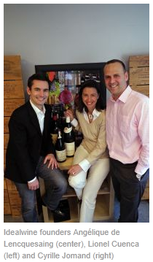
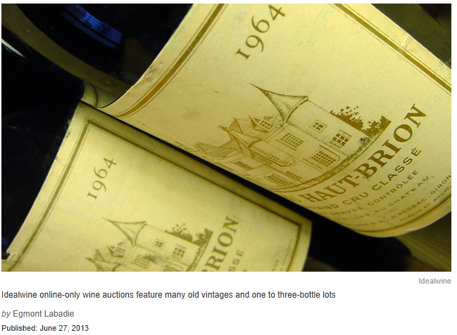
French web company Idealwine has open this Spring an office in Hong Kong to take care of its Asian consumers. Idealwine online-only wine auctions had a €11million turnover in 2012, of which a tenth has been realized with Hong Kong, China, Singapore, Japan and Korea clients. When 70% of its sales was realized in Europe last year, the aim of co-founder Cyrille Jomand is to reach €20million in 2018, a third of it coming from Asia.
As Lionel Cuenca, also a co-founder, states it, “when Hong Kong cut off taxes in 2008, we began to see clients coming to our online auctions, we hadn’t thought about exporting there, but as they were able to come to France to get their lots, we began to do it for them !”
According to Claire Henry, head of the Hong Kong office, “Hong Kong people like the fact that online bidding looks almost like a game, plus they don’t loose time going to in-room auctions without being sure to get their bottles, and we propose many one to three-bottle lots, which allows them to test the wines without having to store an entire case. »
Most of Idealwine lots come from French cellars, which have a great abundance in old wines, allowing Idealwine auctions to often feature more than 50 vintages. And as Claire Henry states it, “our prices are 30 to 50% lower than in the Hong Kong retail, which interests the very educated wine buyers here.” The wines are shipped from France “with an average shipping fare of €6.5 per bottle,” so Cuenca.
As Acker CEO John Kapon told BLOUIN ARTINFO in a recent interview (read here), “wine has become more of a commodity market”, which can explain why the online-only auctions are a growing topic for auction houses. But strategies can differ : when Idealwine chooses to come to Hong Kong, competing for example with Zachys (see their June online auction here), Christie’s prefer to start with the United States and Europe (read full story here).
Idealwine website is also available in Chinese: www.idealwine.com

