Auction | French Wine

iDealwine: French Online Auction Opens Office in Hong Kong
Friday. 7 June. 2013. 10:00 am
French online auction site to offer wine auctions to Asia.
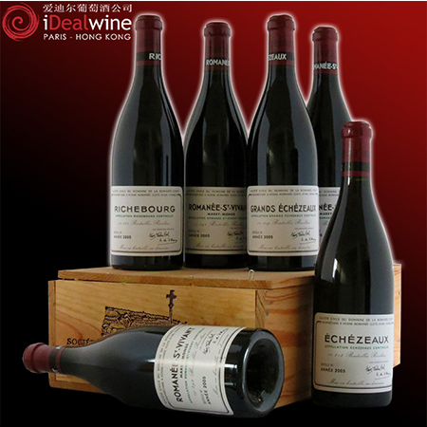
The wine auction market in Hong Kong is one of the biggest in terms of value dollar sales. Its no surprise then to see more players in the market. iDealwine.com – the leading French auction website has opened an office in Hong Kong. iDealwine’s CEO Cyrille Jomand, shares his enthusiasm: “The opening of the Hong Kong-based office for Asia marks an exciting step in iDealwine’s development. 30% of our overall sale revenues come from foreign sales, and Asia is a rapidly expanding part of it.”
iDealwine is an international auction site that allows you to buy, sell and estimate your wines. Established in France, with a presence in Asian since 2009, the website holds monthly auctions and sells high quality mature wines direct from private European cellars and also offer Asian sellers to put their wines up for sale on their site.
In the past, Hong Kong based wine lovers have been able to buy and bid from iDealwine but had to wait for the wine to ship from France. Since 2009 however, improved logistic solutions have been offered to Hong Kong buyers with multiple deliveries per month to all Asia at competitive prices. Orders are grouped through their logistical platform in France and airmailed, before being home-delivered to clients in less that 10 days.
Expect to find the usual wines that goes up for auction from Bordeaux Classified Growth wines, Champagne and Burgundian wines at iDealwine.com.
What’s great is that the wines at iDealwine will be priced attractively at 30% to 50% lower than those sold in Hong Kong and to kickstart the there will be exclusive promotions made available only to Asian buyers. Their June auction ends on June 12 at 4pm HKT and every new user will receive a HK$300 discount on their first order.
Where?
- www.idealwine.com

